Educational Psychology Service

**Emotionally Based School Avoidance – Guidance for Schools**

**Information for schools to support children and young people experiencing Emotionally Based School Avoidance.**



**Plymouth Educational Psychology Service**

Table of Contents

**Introductionpg. 1**

**What is emotionally based school avoidance (EBSA)?pg. 3**

**Prevalencepg. 4**

**Anxiety and EBSApg. 5**

**EBSA and Autism Spectrum Disorder (ASC)pg. 7**

**Risk and resiliencepg. 11**

**Identification, information gathering and planningpg. 15**

**Information gathering and analysispg. 17**

**Working with the childpg. 19**

**Working with the parentspg. 21**

**Working with school staffpg. 24**

**Interpreting information and planningpg. 25**

**Action planningpg. 28**

**Reviewpg. 30**

**Interventions, strategies and resourcespg. 31**

**Whole School good practicepg. 37**

**Transitionpg. 38**

**EBSA and school attendancepg. 40**

**EBSA and Education Health and Care Needs Assessmentspg. 42**

**Further Local support and resourcespg. 43**

**Further resourcespg. 47**

**Referencespg. 52**

**Appendix1 EBSA Vulnerability assessment scalepg. 54**

**Appendix 2 Information gathering from schoolspg. 57**

**Appendix 3 Information gathering and integrationpg. 59**

**Appendix 4 Examples of Support planspg. 60**

**Appendix 5 Whole School Auditpg. 66**

**Introduction**

Emotionally Based School Avoidance (EBSA) is a broad umbrella term used to describe a group of children and children who have severe difficulty in attending school due to emotional factors, often resulting in prolonged absences from school.

It is difficult to estimate the prevalence of EBSA. The UK literature reports that 4% of the UK population engage in school refusal behaviour (Havik, Bru, Ertesvåg, 2015). There is a slightly higher prevalence amongst secondary school students, with peaks around transition periods (Nuttall & Woods, 2013), for example, around the transition from year six to year seven. It is reported that school non-attendance is equally common in males and females, with little evidence of a link to socioeconomic status (Gonzálvez et al., 2018)

The impact of EBSA on children is far reaching. Research has found that school EBSA may seriously hamper children’s psychological, social and academic performance and subsequently performance in exams and employment opportunities (Kearney, 2006; Taylor, 2012).

The current guidance has been produced by Plymouth’s Educational Psychology service and is based on the current evidence base of the factors which are associated with positive outcomes (Baker and Bishop, 2015). These include:

* Intervening early
* Working with parents
* Working in a flexible manner paying attention to the individual case and function served by non-attendance.
* Emphasising the need for rapid return to school alongside good support and adaptations within the school environment.

The Educational Psychology service has also produced information booklets for parents, children and young people and are able to hold training and consultation for school staff and other professionals to supplement this guidance.

This guidance, leaflets and information can be found on the Plymouth Local Offer website.

<https://www.plymouthonlinedirectory.com/plymouthlocaloffer>

and on the Educational Psychology Service Local offer page. <https://www.plymouthonlinedirectory.com/plymouthlocaloffer/educationalpsychologyservice>

The Educational Psychology Service would like to thank members of the following teams for their comments and contributions;

Inclusion and Attendance team, PCC

Communication and Interaction Team, PCC

Community CAMHs

PIAS

SEND Strategic advice and support, PCC

SENCOs from primary and secondary schools

*With thanks to guidance from West Sussex EPS which this booklet has been adapted from.*

**What is Emotionally Based School Avoidance?**

Definition:

Emotionally Based School Avoidance is a broad umbrella term used to describe a group of children and young people who have severe difficulty in attending school due to emotional factors, often resulting in prolonged absences from school. A key distinction is made between those that are absent from school due to truanting and those that are absent from school due to specific emotional distress that they experience around attending school (Heyne et al., 2019).

Although the literature in this area often cites the phrase ‘school refuser’, this terminology could be considered misleading as the term ‘refuser’ implies that the child has control over the school non-attendance. This is problematic as this terminology locates the ‘problem’ within the child and detracts from environmental factors that could be considered instrumental in supporting a child back to school:

“School refusal occurs when stress exceeds support. When risks are greater than resilience and when ‘pull’ factors that promote school non-attendance overcome the ‘push’ factors that encourage attendance”

(Thambirajah et al, 2008: p. 33).

Cause:

There is no single cause for EBSA and there are likely to be various contributing factors for why a child may be finding it difficult to attend school. It is well recognised in the research literature that EBSA is often underpinned by a number of complex and interlinked factors, including the child, the family and school environment (Baker and Bishop, 2015).

Kearney & Spear (2012) found four main reasons for EBSA:

1 – To avoid negative feelings provoked by school-related stimuli.

2 – To escape from social aversion and evaluation, often to avoid being rejected or disliked.

3 – To gain attention from significant others, e.g. parents.

4 – To seek tangible reinforces outside of the school setting, such as going shopping or playing computer games during school time.

According to this model, the avoidance of uncomfortable feelings or situations described in the first two points could be viewed as negatively reinforcing the EBSA, whereas in the second two points, the EBSA could be seen as positively reinforced by factors outside of school (Kearney and Spear, 2012).

**Prevalence**

The UK literature reports that between approximately 4% of the school population with slightly higher prevalence amongst secondary school students, are absent from school due to emotional reasons (Havik et al., 2015; Gulliford & Miller, 2015). It is reported to be equally common in males and females with little evidence of a link to socioeconomic status (King and Bernstein, 2001).

Difficulties children have in articulating their distress and difficulties that parents and school staff have in understanding the child’s emotional experience of school are often key barriers in identifying and supporting children at risk of EBSA.

For some children, the distress may be obvious in their presentation and chronic non-attendance. However, for others, these difficulties may not be easily identifiable. These children may demonstrate sporadic attendance, missing the odd day here and there or particular lessons, or may only be able to attend school when provided with a high level of support and a modified timetable.

The onset of EBSA may be sudden or gradual. The literature suggests there tend to be peaks in EBSA corresponding to transition between school phases.

It is also important to highlight that some children with EBSA may appear to recover relatively quickly from the initial upsets of the morning and this can lead school staff and others to question the legitimacy of the EBSA; however, it is important to hold in mind models of anxiety, as it not unusual for the anxiety to quickly dissipate once the perceived threat is removed (Thambirajah et al., 2008).

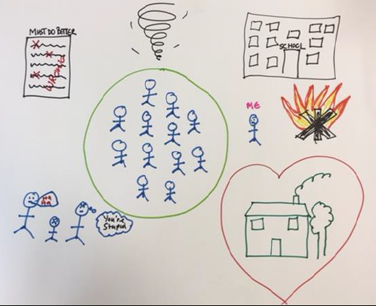

*Figure 1. Picture of a 14 year old drew, her feelings are like a whirlwind where she is not in control, that the school is not a safe place, she worries something bad might happen, she sees schools having lots of people in it, but she is on the outside and that people are making fun of her. She has also indicated that she feels she is not doing well with her work and she loves being at home*

**Anxiety and EBSA**

Anxiety has also been identified as a key feature of EBSA. Although a certain level of anxiety is considered a normal and natural part of growing up, some children may experience heightened levels of anxiety which impact on their functioning and school experiences.

When the anxiety is linked to school avoidance, the child may experience anxious and fearful thoughts around attending school and their ability to cope with school. These feelings may also be accompanied by physiological symptoms of anxiety, such as nausea, vomiting, shaking, sweating etc., and may start the night before or even a few days before school.

In order to avoid these overwhelming emotions and the fear associated with school attendance the child may withdraw from the situation, refusing to get ready for school or to leave the house or enter the school. The child may also turn to hostile behaviours as means to avoid the threatening situation and try to control what feels like a very out-of-control situation (Thambirajah et al., 2008).

These behaviours, and the avoidance of school, may then contribute to the maintenance of EBSA over time, research suggests that it is crucial to consider the child’s perception of their ability to cope, including perceived social and academic competence, as negative thoughts about one’s ability to cope can lead to further feelings of worry and if left unaddressed, may undermine attempts to improve attendance. Likewise, youth with EBSA have more negative thoughts related to failure and are more likely to overgeneralize negative events (Maric, Heyne, de Heus, van Windefelt & Westenberg, 2012).

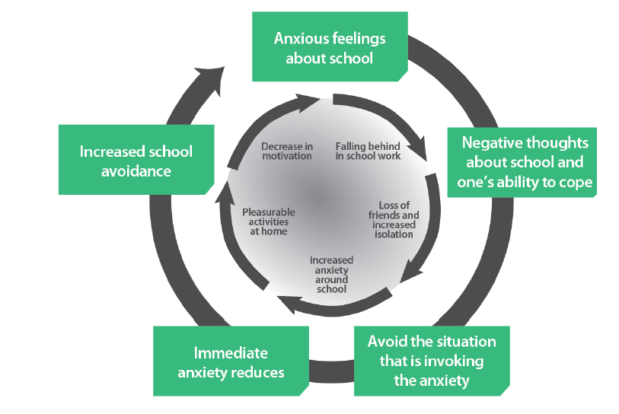

*Figure 2. Diagram showing the initial anxiety causing the non-attendance and the secondary maintenance factors.*

**EBSA and Autism Spectrum Condition (ASC)**

It is well documented that anxiety and poor stress management are common in children with autism and that anxiety may worsen during adolescence, as children face increasingly complex social interactions and often become more aware of their differences and interpersonal difficulties. As yet, there is little research into the prevalence of those with ASC and EBSA but evidence and experience suggests that due to the anxieties that the children with ASC experience they are at increased risk of EBSA.

The factors which influence levels of anxiety in those with ASC, as with any child, are multiple and often complex; associated with context blindness, executive functioning, limited theory of mind, difficulties processing language, focus on detail, sensory processing differences (Ozsivadjian and Knott 2016; Gaus 2011; McLeod et al 2015; Ting and Weiss 2017). Recent research also considers intolerance of uncertainty (IU) as a key contributing factor to anxiety in children with ASC.

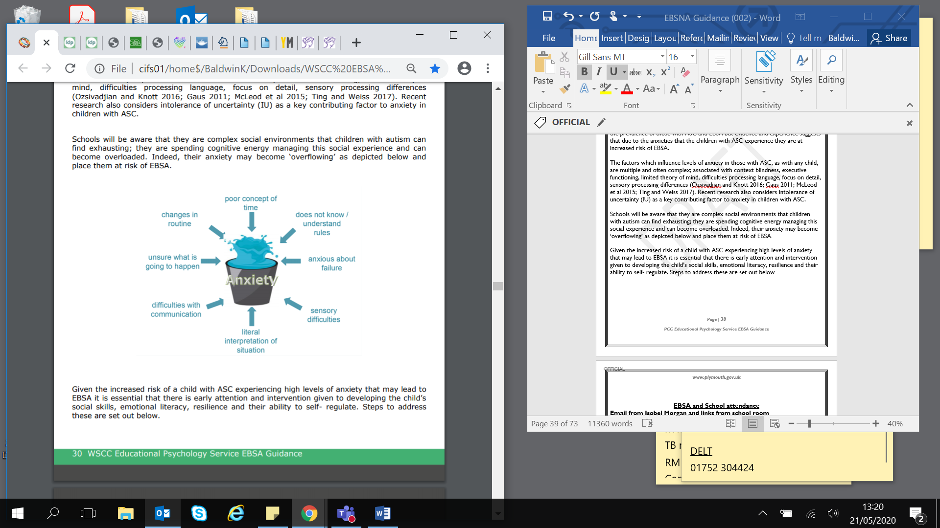Schools will be aware that they are complex social environments that children with autism can find exhausting; they are spending cognitive energy managing this social experience and can become overloaded. Indeed, their anxiety may become ‘overflowing’ as depicted below and place them at risk of EBSA.

Given the increased risk of a child with ASC experiencing high levels of anxiety that may lead to EBSA it is essential that there is early attention and intervention given to developing the child’s social skills, emotional literacy, resilience and their ability to self- regulate. Steps to address these are set out below.

*Working with the child with Autism*

Evidence and experience demonstrates that anxiety levels in children with ASC can be reduced by adopting good practice approaches that are individualised to the child’s specific needs including visual supports, structure, managing change and generally increasing the certainty of the school day.

Further details of good practice strategies can be found in below – Strategies for Children with ASC and should include all adults working with a child being made aware of the affect their communication style can have.

All adults working with the child:

* Use child’s name before delivering any instructions so that they cue into you speaking to them and recognise the instructions applies to them.
* Allow additional time for the child to process verbal information and instructions (at least 10 seconds) and avoid repeating verbally within this time.
* If repetition of the information/instruction is necessary use exactly the same wording as initially used.
* Use explicit, concise language when addressing the child as this is likely to enable them to process the information correctly.
* Use short simple instructions. Give them in order that they are to be completed. Check for understanding. Ask the child to repeat them back to you

*Steps to Support Reducing Anxiety*

Step One Ensure that all adults working with the child have an understanding of ASC and communicate appropriately and that adults have implemented general autism ‘good practice’ strategies e.g. the child uses and is engaged with a visual timetable, relevant visual supports, calm space – see below for further suggestions.

Step Two Key to the effectiveness of any intervention is having a sound understanding of the child’s needs and how ASC specifically affects the child. Consider using a tool such as:

* Pupil Progression tool - Autism Education Trust (AET 2017)
* *Autism from Diagnostic Pathway to Intervention* by Kate Ripley

Step Three Plan and implement individualised, strategies to develop the emotional and social skills identified in step two. These may include those identified for children in previous chapters of the guidance or more specific strategies such as those included in the resources section.

Step Four Review the impact of the interventions using the Pupil Progression Tool (AET) or similar. It may be that, despite the good practice and interventions, the child’s anxiety continues to increase placing them at risk of EBSA and additional interventions will require implementation.

Please note that the advice in previous chapters regarding Action Planning are also relevant here and should be followed.

If there are indications that the child is at risk of EBSA it will be important to build up a clear picture of exactly what elements of attending school are increasing their anxiety in order that best endeavours can be made to alleviate the anxiety. It is recommended that the tools in Autism from Diagnostic Pathway to Intervention by Kate Ripley are used. In particular, Mapping the Landscape of Fear and planning solutions.

*Working with Parents*

Recent studies, (Reaven et al., 2012; Steensel, Zeger and Bogels, 2017, Ting and Weiss, 2017) emphasise the importance of the relationship between parental anxiety and anxiety in children and young people. Many parents of children with autism report that they notice their own emotions have an impact on their child’s emotions and vice versa. Therefore, it important to emphasise the need for school to build a collaborative partnership with parents in the best interest of the child, as described previously.

Parents may have received guidance regarding strategies to support their child and schools should consider training courses that may be available to parents from CAMHs and the Child Development Centre.

**General Strategies for Supporting Children with Social Communication**

**Disorder and Autism Spectrum Condition in the Classroom**

**All adults** working with student should be made aware of the following:

* **Use student’s name before** delivering any instructions so that they cue into you speaking to them and recognise the instructions applies to them.
* Allow additional time for the student to process verbal information and instructions (at least **10 seconds**) and avoid repeating verbally within this time.
* If repetition of the information/instruction is necessary **use exactly the same wording** as initially used.
* Use **explicit, concise language** when addressing the student as this is likely to enable them to process the information correctly.
* Use **short simple instructions**. Give them in order that they are to be completed. Check for understanding. Ask the student to repeat them back to you.
* **Do not** insist on **eye contact**, for many students with autism this can be uncomfortable and in extreme cases even painful. Instead consider agreeing a strategy with the student and all staff to enable them to indicate that they are listening.
* Be aware that direct answers from the student are often related to their **literal understanding** and lack of social awareness rather than due to **rudeness.** Ideally consider developing a **pen portrait profile** to share with all staff, including office staff and midday meals supervisors to ensure awareness of the above.

**Classroom Strategies to consider;**

* Ensure the student understands how to use their planner; **colour coding the information including the map** will be beneficial. This will lower the anxiety levels associated with SCD/ASC and enable the student to predict what is coming next.
* Be aware that clear explanation needs to be provided, supported visually where possible, **to explain any unplanned changes of routine** to the student in **advance.**
* **Use visuals** to remind students of expected behaviours, classroom rules and routines for example, use symbols to indicate noise levels i.e. partner voices, group voices, classroom voice, social voices. This will also encourage independence.
* Provide the student with a **symbol card to display when he or she wants help.**
* Provide **an area of classroom** free from busy displays and distractions. Try to keep the area around the whiteboard / IWB ‘clutter free’.
* Wherever possible provide the student with a **visual set of simple step by step instructions** that they can use as a tick list. This will also support independence.
* It is common for children with SCD/ASC to be resistant to writing. There are numerous skills involved in writing from retrieving ideas/memories to fine motor skills. Therefore, consider **providing opportunities to complete learning objectives using alternative means of recording** e.g. scribe, keyboard, audial recording etc.
* Consider the use of **mind mapping software** to support students through visual learning. Various packages are available. E.g. Clicker 7.
* Consider allowing the student to achieve the learning objective through writing about their own interest instead of the topic under consideration.
* The student will benefit from being given a clear indication of the expected outcome of a task before they start i.e. what finished will look like. **Set tasks with clear goals** e.g. Write ‘x’ number of sentences on” rather than “Write about…”, or the use of a green dot to indicate where the writing will start and a red dot where it will end or state the number of calculations etc.
* Prevent repetitive questioning or commenting during class discussion by giving the students set number of cards (**talk tokens**) to give you each time they wish to contribute to discussion –when cards are gone, no more questions. Alternatively, use them to encourage participation from students who are reluctant to contribute.

**Managing sensory processing difficulties**

* The student with sensory processing difficulties often struggles with the basic skills of managing his/her responses to ordinary sensations, of planning and organising their actions and of regulating their attention and activity levels. They may present sensory seeking or sensory avoiding behaviour. Completing a sensory checklist (available from the Communication Interaction Team) can help to identify such sensory responses.
* Sensory activities should be timetabled into the student’s day reflecting the needs identified in the sensory checklist.

**Motivating the Student**

* Use **incentives based on an activity that is personally motivating** to the student/their interests e.g. I.T. based activities/games, Dr Who, Pokémon Go.
* Use **individualised reward systems** e.g. collecting a number of points or ticks that achieve a personally motivating reward. Earned points/ticks should not be removed for poor behaviour. The collection of point/ticks should not be linked to specific periods of the day.

**Self-regulation**

* The student who has difficulties with self-regulation may have difficulty managing/moderating their behaviour, their emotions, their sensory reactions or the focus of their attention (cognitive self-regulation).
* It is important to observe students and use tools such the **ABC or STAR behaviour charts** to unpick where they may have difficulties in self-regulation then begin working with them to develop strategies to manage their difficulty including **traffic lights, scaling and self-advocacy**. Consider using resources such as **‘The Incredible 5 Point Scale’** – see below for details.

**Developing Social Understanding**

* A **small step target approach** should be taken using checklists/resources to set the targets and assess the Student (available from the Communication Interaction Team).
* Link any social target to a reward system that is personally motivating to the student.
* Use **‘catch me cards’** to target specific social targets throughout the school day e.g. ‘Catch me doing as I am asked’,– each time an adult witnesses the student achieving the target they initial or stamp the card so they can see their progress and it can be rewarded.
* Develop the student’s understanding of social rules and situations using[Social stories and comic strip conversations (autism.org.uk)](https://www.autism.org.uk/advice-and-guidance/topics/communication/communication-tools/social-stories-and-comic-strip-coversations).These will help the student to begin to understand how other people feel in different situations and provide them with strategies to use.
* Consider including the student in a **social skills group** that uses explicit teaching of the skills required to achieve their social target e.g**. Lego Therapy**. The Communication Interaction Team can provide training for staff to implement this.

**Risk and Resilience factors of EBSA**

EBSA is a heterogeneous concept (Maynard et al., 2015). This means that it cannot be treated as a single condition. Different children will be hesitant to attend school. Different children will be hesitant to attend school for different reasons. It is usually a combination of various factors and their interaction rather than a single cause that leads to EBSA.

Risk: just as with general mental health there have been factors identified that place children at greater risk of EBSA. It is usually a combination of predisposing factors interacting with a change in circumstances which leads to the pattern of behaviour described as EBSA.

**Table 1: Risk Factors**

|  |  |  |
| --- | --- | --- |
| **Child factors** | **Family factors** | **School factors** |
| Anxiety and depression- anxiety around going to school, separation anxiety, social anxiety  Age (5-7, 11, 14)  Negative style of thinking, low  self-efficacy and limited problem solving  somatic complaints & illness | Parental overprotection  Mental health problems in parents  Dysfunction within family  Marital crisis, separation and divorce | Bullying  Social isolation and loneliness  Academic difficulties- poor grades, special educational needs learning disorders  Lack of teacher support, conflict or fear of teachers  Unpredictability of school environment (noisy classrooms, break times, toilets)  Anxiety about academic performance  Inability to meet academic demands of school  Transition to secondary school, key stage or change of school |

**Resilience:**

When working with individuals it is really important to also identify and build areas of strength or resilience of the child, family and school which may help to ‘protect’ the child and promote school attendance.

This may include:

* Developing ambition, aspiration and motivation
* Increasing confidence, self-esteem, self-efficacy, value in themselves.
* Developing feelings of safety, security and a sense of belonging.
* Having positive experiences where they can succeed.
* Holding positive relationships with peers or staff.
* Feeling listened and understood.
* Understanding the relationship between thoughts, feelings and behaviours.
* Willingness to work in partnership between school, family and external professionals.
* Developing parenting skills and understanding.
* Flexibility of approaches within school, person centred listening to the voice of the child.

**Case study: Identifying risk and resilience factors**

I was asked to meet Pupil X at a late stage in her school avoidance. Her attendance had been falling for over a year. Her parents had been called to an ‘interview under caution’. They felt that they had run out of ideas to get her to school although she did attend occasionally.

She spent a lot of time gaming on a computer in her bedroom and this often led to family arguments. Her parents have health problems and this was adding to the stress in the home. She can become aggressive if asked to stop playing and this means she played late into the night. In the mornings she is then too tired to get up for school. She would rather not attend than be late. She has an older brother who stopped attending school in Year 9.

She has an autism spectrum condition and mild asthma. In my discussion with her I found that she likes talking to adults in school and she has friends in school. She sees her friends outside of school and likes to go swimming with them. She is concerned about being behind with lessons due to her absence and she does not have a clear view of what she would like to do when she leaves school. When using the Kearny Scale there did not appear to be an obvious reason for the non-attendance.

An Education Welfare Officer is involved and their ideas for strategies are put into place at home.

**‘Push’ and ‘Pull’**

The literature suggests that these contributory factors of risk and resilience can also be divided and understood, in terms of ‘push’ and ‘pull’ factors.

* Push factors – those that push the child towards attending school.
* Pull factors – those that pull the child away from attending school.

The literature indicates that emotionally Based School Non-Attendance is most likely to occur when the risks are greater than resilience, when stress and anxiety exceeds support, and when the pull factors that promote school non-attendance overwhelm the ‘push’ factors that encourage school attendance.

Example of “Push” and “Pull” factors from above case study:

|  |  |
| --- | --- |
| SCHOOL | HOME |
| PUSH ( to school)  • Supportive group of friends in school  • Does want to attend  • Parents are supportive of attendance  • Academically able in lessons | PULL (away from school, home factors)   * Too tired to wake up on time in the morning (stays up late gaming) * Anxiety about parents’ illness * Prefer to be using games console at home * Parents’ feeling of lack of ability to help |
| PULL (away from school, school factors)  • Doesn’t like being told off publicly in lessons  • Doesn’t like being sent to isolation  • Doesn’t have a clear goal / career plan  • Doesn’t understand or see the benefit of going   * Anxiety about being behind and unprepared for exams due to non-attendance | PUSH (towards home)   * Can be at home to support parents if ill * Don’t have to face lessons * Can spend more time gaming |

**Identification, information gathering and planning:**

Schools play a key role in the identification of children and children who are currently experiencing, or at risk of EBSA. It is important for schools to develop effective whole schools systems to support children, be vigilant to early indicators and employ a thorough assess, plan, do and review cycle placing the child at the heart of the interventions.

**Potential indicators:**

It is very important to be proactive with EBSA. The longer the problems remain unaddressed the poorer the outcome, as the difficulties and behaviours become entrenched. Schools need to be vigilant in monitoring attendance of children noticing any patterns in non-attendance or changes to behaviours.

The Plymouth Vulnerability assessment scale can be found in Appendix 1. This can help practitioners identify areas of risk. The checklist is for use alongside the usual attendance monitoring systems in school, e.g. SIMS and consideration of patterns of attendance, to screen for possible EBSA in relation to nonattendance.

|  |
| --- |
| **Possible Indicators of EBSA include:** |
| * Difficulty attending school with periods of prolonged absence |
| * Child reluctant to leave home and stays away from school with the knowledge of the parent/carer. |
| * For younger children, reluctance to leave parents or get out of the car |
| * Regular absences without indication of anti-social behaviours |
| * Frequent absences for minor illnesses |
| * Patterns in absences, for example, particular days and/or subjects, after weekends and holidays. |
| * The child expresses a desire to attend classes but is unable to do so |
| * Reluctance to attend school trips |
| * Anxiety on separation and inappropriate defence on family members, e.g. worry expressed about the safety of those at home. |
| * Evidence of under-achievement of learning potential |
| * Social isolation and avoidance of class mates or peer group |
| * Challenging behaviours, particularly in relation to specific situations at school |
| * Severe emotional upset with excessive fearfulness, outburst of temper and complaints of feeling ill on school days |
| * Depression and sense of isolation, resulting in low self-esteem and lack of confidence. |
| * Confusion or extreme absent-mindedness shown in school due to lack of concentration resulting in lower attainments. |
| * Physical changes, i.e. sweating, sickness, aching limbs, headaches, panic attacks, abdominal pain, rapid weight loss or gain. |

Where significant risks of EBSA are identified, it is really important to gather further information from the child, parent and school staff involved with the child and put into place strategies to support the child as soon as possible. Swift action can prevent EBSA from becoming entrenched and result in much better outcomes. School should follow a thorough assess, plan, do and review cycle placing the child at the heart of the planning and interventions.

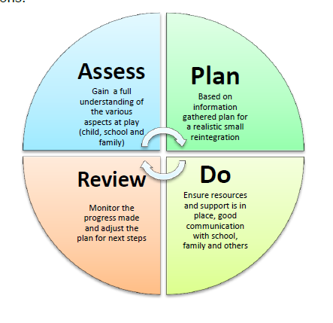

**Information gathering and analysis**

Once a difficulty has been identified there should be a prompt investigation into the reason for the difficulties. In order for any intervention or support plan to be successful it is essential to gain an understanding of the various aspects causing and maintaining the EBSA behaviours.

Thambirajah et al. (2008) state that the main aims of this analysis is to:

* To confirm that the child is displaying EBSA as opposed to truancy or parentally condoned absence.
* To assess the extent and severity of (a) school absence, (b) anxiety and (c) ascertain the types of anxiety.
* To gather information regarding the various child, family and school factors that may be contributing to the EBSA in a given child.
* To integrate the available information to arrive at a practical working hypothesis as a prelude to planning effective interventions

It is often tempting to try to locate a simple reason and simple solution for the behaviour.

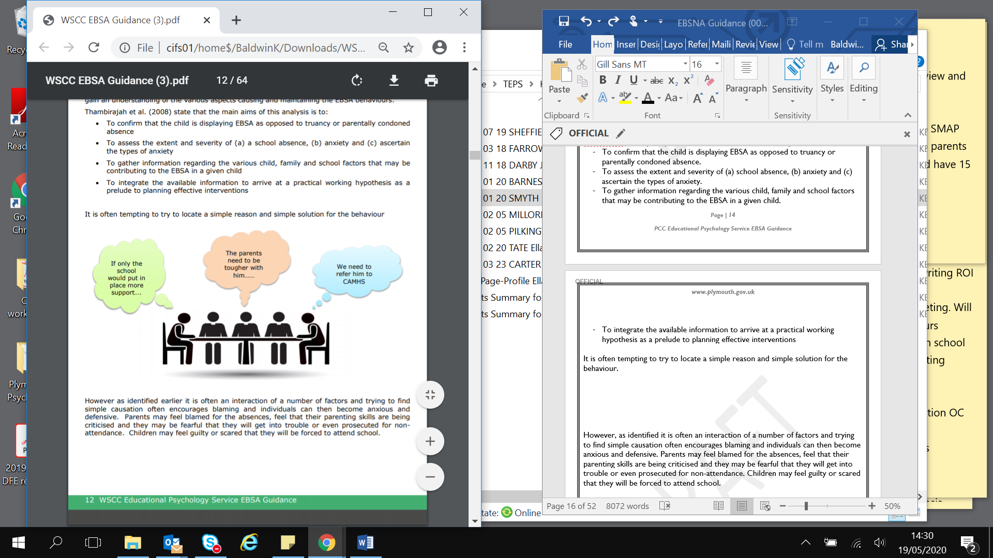

However, as identified it is often an interaction of a number of factors and trying to find simple causation often encourages blaming and individuals can then become anxious and defensive. Parents may feel blamed for the absences, feel that their parenting skills are being criticised and they may be fearful that they will get into trouble or even prosecuted for non-attendance. Children may feel guilty or scared that they will be forced to attend school.

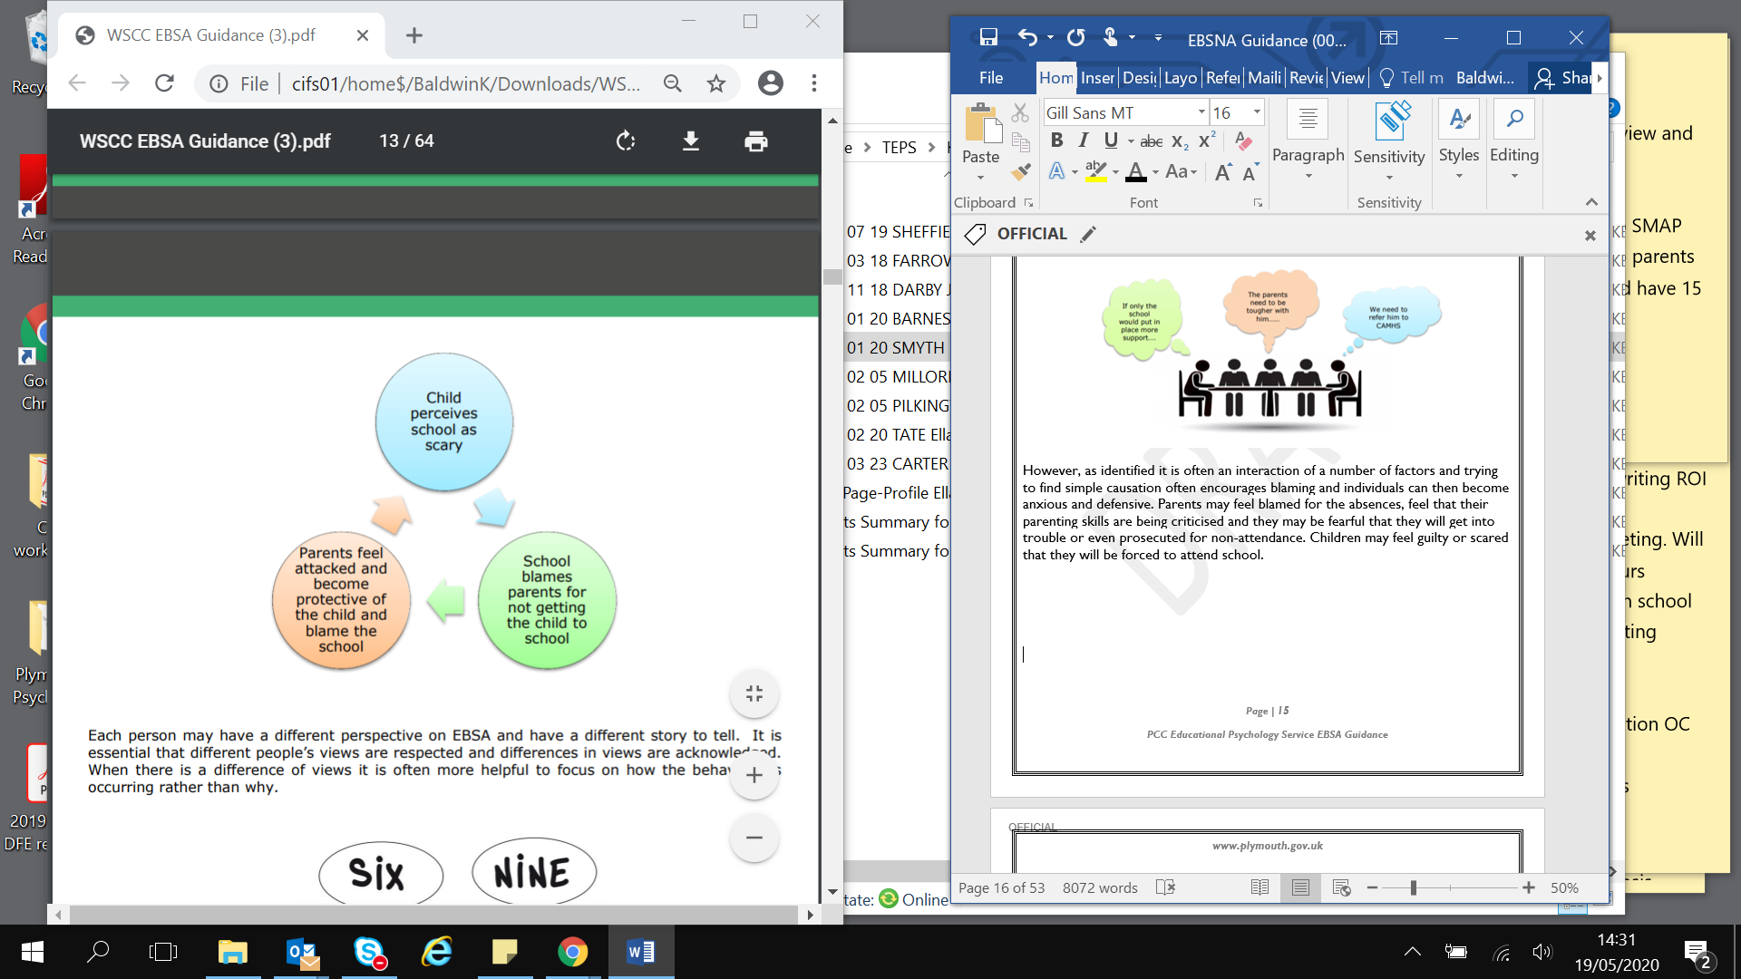

Each person may have a different perspective on EBSA and have a different story to tell. It is essential that different people’s views are respected and differences in views are acknowledged. When there is a difference of views, it is often more helpful to focus on how the behaviour is occurring rather than why.

Kearney (2006) revised the School Refusal Assessment Scale-Revised (SRAS-R), a functional assessment tool designed to identity school refusal behaviours in children and child and their reasons for non-attendance. This self-report inventory is designed for children ages 5 and up, and is also completed by parents. Each item in the question set are based on a different function which may be contributing to their non-attendance. The function with the high mean, based on child and parental responses, is considered the primary cause of the child’s non-attendance. The function divisions are as discussed above:

* To avoid negative feelings provoked by school-related stimuli.
* To escape from social aversion and evaluation, often to avoid being rejected or disliked.
* To gain attention from significant others, e.g. parents.
* To seek tangible reinforces outside of the school setting, such as going shopping or playing computer games during school time.

Due to the complex nature of EBSA no fixed ‘assessment process’ can be followed. However in all cases it is essential that the views of the child, the family and key school personnel are gathered and listened to.

**Working with the child**

Any child currently avoiding school will become anxious when asked to discuss returning. They currently manage feelings of anxiety by employing the avoidant behaviour of not going to school, so any talk about going back to school is going to raise their anxiety as you are proposing to take away their way of coping with their fears. A good place to start any assessment with a child is to acknowledge it may be difficult but you would like to know what they think and feel. It is important that the adult does not dismiss anxieties or worries the child has, empathise with the child but do not collude or promote the EBSA.

The approaches taken will depend on the child’s age, level of understanding and language. Even if they are able, often children find it difficult to verbalise what they are thinking and feeling and they may prefer to draw what they are feeling or have visual prompts.

*Some example activities or questions could include:*

Think about your thoughts and feelings about school and what these would look like if they could be drawn?

It also helps to externalise the anxiety:

* What name would you give the feeling that you experience when you think about going to school?
* If it was a thing, what would it look like? What would it say?
* How does the …… get in the way of you attending school? When is ……….. in charge and when are you in charge?

Ask them to draw how their body feels when they are worried. Use an anxiety thermometer or a scale to ask the child what aspects of school they find difficult some areas to consider include:

* The physical environment e.g. toilets, corridors, assembly hall.
* Times of the day or social interactions e.g. arriving at school, play and break times, lining up to go into school or classroom, lunchtimes, going home, changing for PE
* Particular lessons or activities within lessons e.g. writing, working as part of a group, reading aloud, verbally answering a question

A life graph or path can help them tell you their ‘story so far’ and what they would want in the future.

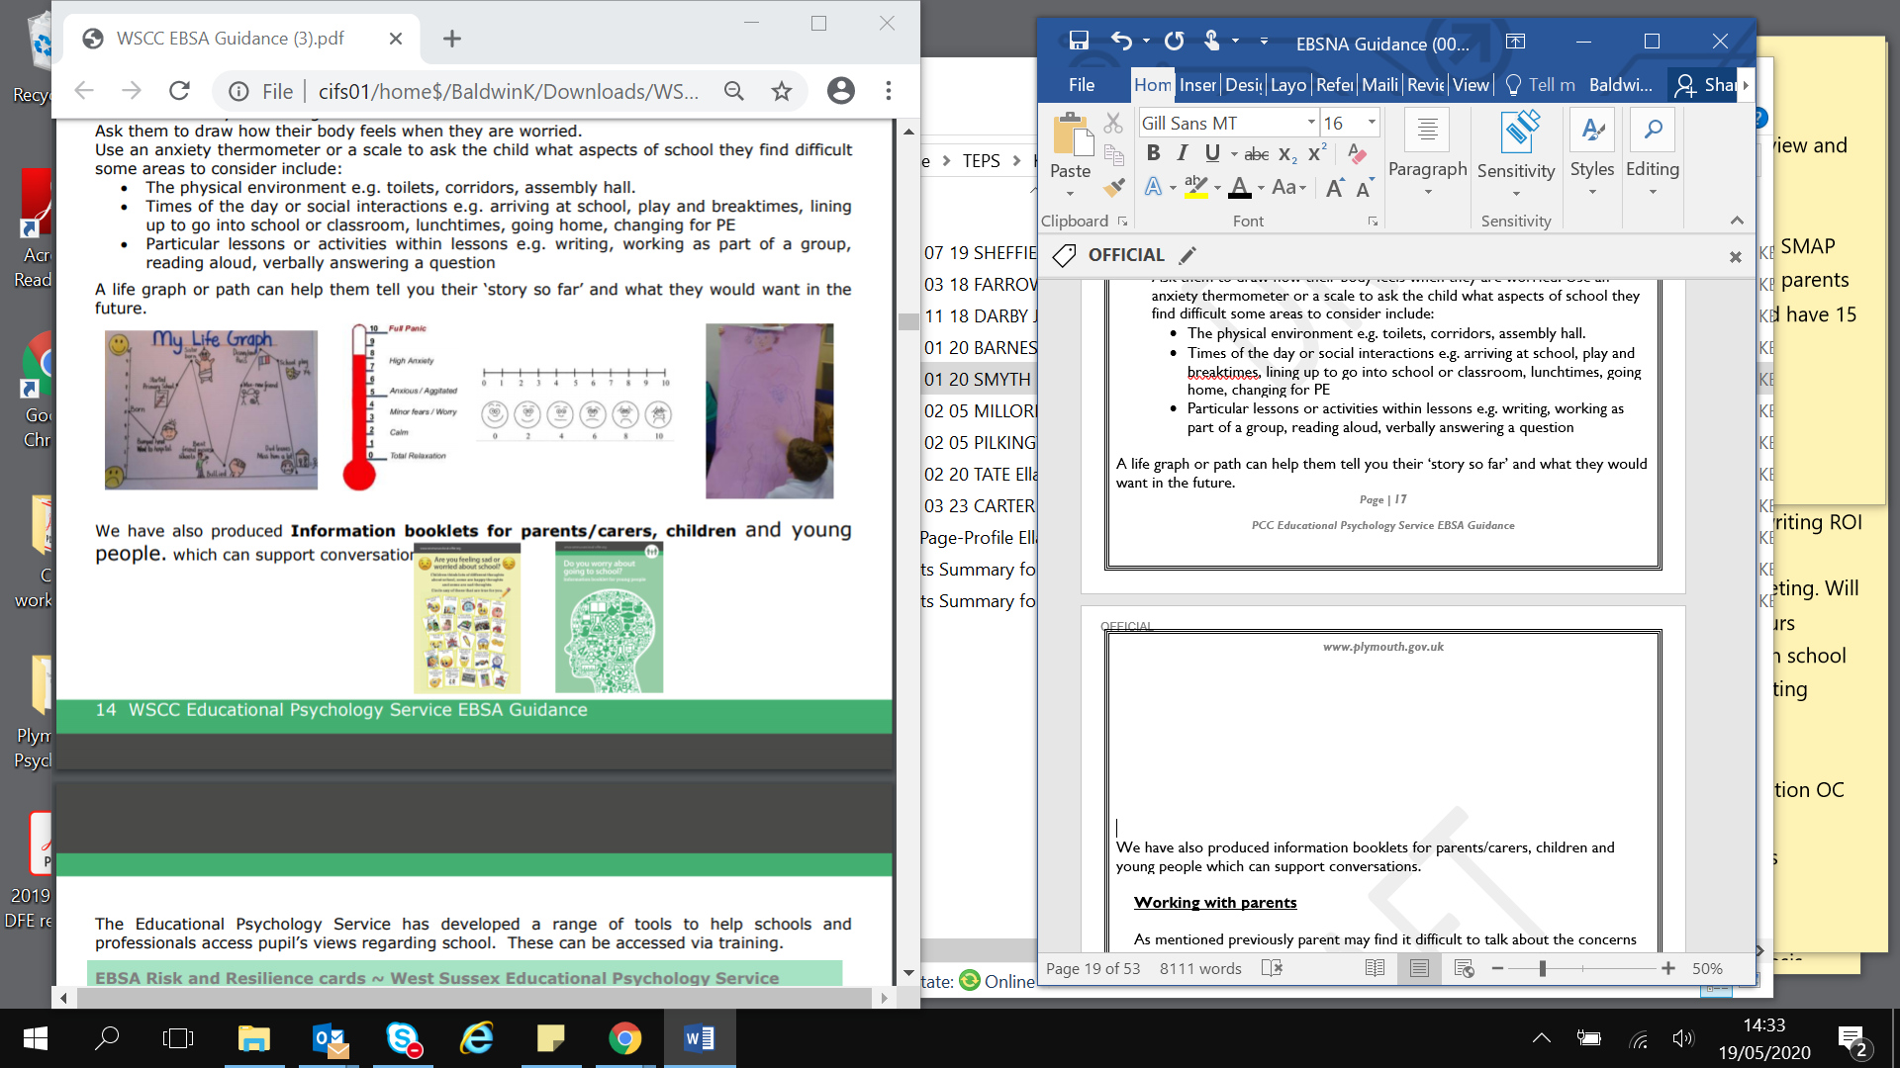

We have also produced information booklets for parents/carers, children and young people which can support conversations.

**Working with parents**

As mentioned previously parent may find it difficult to talk about the concerns they have and the difficulties they experience in trying to get their child into school. It is important that school take time to build a collaborative partnership working together in the best interest of the child. Sometimes parents may have had similar experiences to their child and may experience their own anxiety making it especially difficult for them.

During the initial meeting it is important to gather background information, establish the current situation and parents views. Questions should be sensitive and the person asking should employ active listening skills. School staff should identify who will be the key person to communicate with parents and agree how they will do this.

Working with parents is essential to successful outcomes. While the focus is on the child is also important to remember that parents may need their own support and consideration should be made to referrals services, such as Plymouth Information Advice and Support Service for SEND, details can be found in the further local support and resources section.

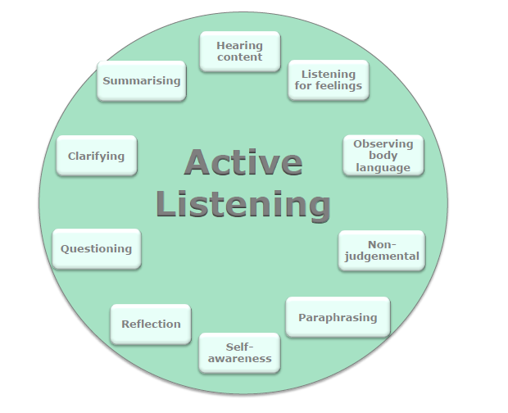

|  |  |
| --- | --- |
| **Areas to cover** | **Example questions** |
| **Developmental and educational history** | What was s/he like as a young child? Can you tell me about their early experiences at school? The primary school, at the start of secondary school? |
| **Strengths, interests and aspirations** | What is s/he good at? What do they like doing? Do they have any hopes for the future? Do they know what they want their life to be like when they are an adult? |
| **Any potential changes or losses within the family or child’s life** | Can you tell me about your family? Who is in it, who is like whom. Who is s/he closest to? Have there been any changes within the family recently? (You could ask them to draw a family tree/ genogram). |
| **Relationships** | Does s/he talk about any other children? What does s/he say? Does s/he talk about any adults within school? What does s/he say? Who does s/he get on with…who doesn’t s/he get on with? |
| **Academic progress** | School should be aware if the child has identified SEN needs and should ask about these needs and the support in place. If there is no identified SEN school should ask if they have any concerns, or if the child has spoken about difficulties. |
| **The child’s view what are their specific fears/worries** | Has s/he spoken to you about what s/he finds difficult about school? What do they say? |
| **The child’s views, what is going well in school** | Has s/he mentioned anything that is going well in school? (e.g. teachers, lessons, friends) |
| **Behaviour and symptoms of anxiety** | When s/he is worried what does it look like? What do they say they are feeling? |
| **Typical day – when they go to school and when they don’t go to school** | Please describe a typical day when s/he goes to school from the moment s/he…gets up until s/he goes to bed……. and when s/he doesn’t go to school? What does s/he do when they do not go to school? What do other family members do? |
| **Impact on various members of the family** | How does their non-attendance impact on you? And on other family members? Who is better at dealing with the situation? Why? |
| **Parental views on the reasons for the EBSA** | Why do you think s/he has difficulty attending school? (ask each parent separately) If (other parent/ sibling/Grandparent) were here what would they say? Are there any differences of views about the reasons and what should be done within the family? |
| **Exceptions to the problem** | Have there been times when s/he managed to get into school? What was different about those times? |
| **Previous attempts to address the problem** | What has been the most helpful thing that someone else has done in dealing with the problem so far? What has helped in the past when things have been difficult? What strategies have been most helpful so far in managing their anxiety? |

**Working with school staff**

It is essential that representatives from schools seek information from members of staff who work most closely with the child or child. We all respond differently according to the environment, situations or task and with different people. Each member of staff may have valuable information to help identify triggers for anxiety and strategies the child responds positively to. In particular it is important to seek out the views of any members of staff the child speaks positively about and any member of staff where relationships may be more difficult. This might include Emotional Literacy Support Assistants (ELSAs) in Primary Schools and Pastoral Support Staff in Secondary Schools.

Key information to gather includes:

* The child’s strengths
* What is going well
* Any difficulties they have noticed
* Peer relationships
* Relationships with adults
* Response to academic tasks
* If they have witnessed emotional distress what did thus look like and what caused it.
* What support or differentiation is put in place and how the child responds to this
* Any ideas for further support

An example of a ‘round robin’ form can be found in Appendix 2, Information gathering from school. It is also essential to consider whether the child has unidentified special educational needs, medical needs or a disability. If they are not already involved school staff should consult with the school’s special educational needs co-ordinator (SENCO).

**Interpreting the information and planning**

Following the gathering of information from the child, family, school and any other professional it is essential that this information is gathered together and ‘sense’ is made of it. That an overview of the whole picture and various factors involved are obtained and potential hypothesis are formed. These should then inform the return to school support plan.

The form below is designed to help you integrate the information gathered from the child, school and family. It is not designed to be a questionnaire but a tool to be completed after the information gathering to help you collate, integrate and analyse the information gathered form a variety of sources. A blank copy can be found in Appendix 3 Information gathering and integration.

At the Formulation and Integration Stage schools can access telephone consultation support from the Educational Psychology Service to assist in the identification of function of the EBSA behaviour and inform the subsequent action planning and intervention

|  |
| --- |
| **Description of behaviour** |
| * What is the current rate of attendance? * Are there any patterns to non-attendance? Particular days or lessons? * History of behaviour; when did it first occur? Have there been similar difficulties? * Behaviour and symptoms of anxiety – what does it look like? What does the child say about any specific fears and difficulties? |

|  |
| --- |
| **Risk facts school, child and family** |
| * Developmental and educational history (Health, medical, sensory or social factors) * Any changes in family dynamic? (Separation, loss, birth of a sibling, health issues of other family members) * Any other needs within the family? |
| **Strengths and protective factors** |
| * What strengths does the child have? * Do they have any aspirations or ambitions? * What positive relationships do they have at home and at school (peers and staff)? * What positive experiences have they had at school? * What was different about the times when they child was able to get into school? * What has been helpful in the past? |

|  |
| --- |
| **Formulation and integration of various factors** |
| * What is people’s understanding of why the child is demonstrating these behaviours? * Are there any difference in views? * What risk factors have been identified (child, school and family)? * What strengths have been identified that can built upon?   What is the function of the behaviour? Is it:   * To avoid something or situations that elicits negative feelings or high levels of stress (e.g. fear of the toilets; the noise in the playground; lots of people moving all together in the corridors between classes, tests/exams) * To escape difficult social situations (e.g. feeling left out at playtime; reading out loud in class or other public speaking/group task; working as part of a group) * To get attention from or spend more time with significant others (e.g. change in family dynamic, concerned about the wellbeing of a parent) * To spend more time out of school as it is more fun or stimulating (e.g. go shopping, play computer games, hang out with friends) * Are there any maintaining factors? |

**Action Planning**

After the information gathering and analysis process has occurred a return to school or support plan should be made referring to the Plymouth Graduated response to inclusion documents which can be found by clicking this link: <https://www.plymouthonlinedirectory.com/plymouthlocaloffer/sencoguide/graduatedapproach>

All plans need to be co-produced with parents, the child and any other appropriate agencies. All parties need to be signed up.

Each plan will be different according to the actions indicated by the assessment, what worked with one child will not necessarily work with another.

The plans should always be realistic and achievable with the aim of reintegrating the child. An overly ambitious plan is likely to fail. The return should be gradual and graded and recognition by all that a ‘quick fix’ is not always possible. A part time timetable may be necessary as part of this process but this should always be temporary and not seen as a long-term option as all children are entitled to a full time education.

All parties should be aware that there may be difficulties implementing the plan and these should be anticipated and solutions found. An optimistic approach should be taken, if the child fails to attend school on one day, start again the next day. Parents and school should anticipate that there is likely to be more difficulty after a school holiday, period of illness or after the weekend.

At the start of the plan the child is likely to show more distress and all should be aware of this. School staff and parents need to work together to agree a firm and consistent approach. Any concerns about the process should not be shared with the child a ‘united front’ is recommended. Any concerns should be communicated away from the child.

Schools should take an individual and flexible approach to the child’s needs. All school staff that will come into contact with the child should be aware of the return to school plan and any adaptations to normal routines or expectations that are in place to support the child.

Once actions on a support plan are agreed with a child, e.g. returning to school in very finely graded steps, stick to what has been agreed for that week, even if things seem to be going really well, as pushing things further than agreed can heighten anxiety, reduce trust and backfire overall.

The format of the support plan should be flexible. If appropriate a child’s version should be created. Examples of a support plan can be found in Appendix 4 Example support plans.

Literature has identified key elements of support that should be in place in order for reintegration action plan to be successful.

|  |
| --- |
| **Key elements of any plan** |
| Direct telephone contact between parent/carers and key workers in school. Agree expectations regarding frequency of contact and set realistic response times. |
| A return to school at the earliest opportunity. |
| Early home visits if appropriate to discuss the child’s reluctance to attend school. |
| All parties to agree to actions and keep to them until the new review date. |
| A personalised programme for each child (e.g. flexible timetable, arrangements for transport, buddying, and provision of a safe haven). |
| Ensuring the child has access to an identified member of staff who can be approached if anxiety becomes temporarily overwhelming in school (i.e. a key worker). |
| Ensuring all staff (including supply staff) are informed about the child’s difficulties, particularly during changes of classes/key stages. |
| Identifying a safe place or base in school that the child can go to if needed. |
| Identifying a member of staff for the child to ‘check in’ with throughout the day. |
| Considering whether or not a family assessment using the Early Help Assessment Tool would be helpful. |

**Review**

It is essential that any support plan is regularly reviewed. There should be set dates for reviewing how any support plan is progressing and key personnel to attend identified. It is essential that the children and parents are actively involved in the review.

The review should identify and celebrate any progress made, review whether further information has come to light to help inform clear next steps. These next steps can include:

* Consolidating and maintaining the current support plan,
* Setting new outcomes and or actions for the child, school and parents.
* Identifying that further consultation with other agencies needs to occur which may, if necessary, lead to a referral to other services.



**Interventions, strategies and resources**

Kearney and Silverman (1990) suggest that choice of intervention should be governed by a careful functional analysis of school avoidance behaviour. They describe four types of variable which can maintain school avoidance behaviour, however several of these may be involved and their effects will be interactive. Interventions should be bespoke to the individual and based upon the information which was gathered in the assessment and integration stage.

1. **To avoid something or situations that elicits negative feelings or high levels of stress** (e.g. fear of the toilets; the noise in the playground; lots of people moving all together in the corridors between classes, tests/ exams)

Interventions should include learning about anxiety and worrying, how it affects our thinking, feeling and behaviour. How avoidance of the feared situation makes things worse. The child should be taught anxiety management techniques such as relaxation training and deep breathing. Links to resources to support schools in this can be found in the Resource Section.

There should be a gradual re-exposure to school setting using avoidance hierarchy created with the child from least feared school situations to most feared. School should consider the provision of safe spaces that pupils can go to, such as pastoral zone, and library, these may be less stigmatising for some pupils than learning support area for some pupils.

**Fear ladder (Thambirajah et al., 2008)**

To create a fear ladder, the child can be asked to name situations (or shown cards representing possible fears) and asked to rank them in terms of how they feel about that situation or object from least worried about to most worried about. When thinking about next steps it is important to start with the item that causes the least amount of anxiety, helping them think about how they will cope with this situation and what support they will need. When they have overcome this fear and consolidated this a number of times then they can begin to work his or her way up the hierarchy.



**Most feared**

**Least feared**

Going into the classroom

Getting ready in the mornings

Getting into the car

Having worrying thoughts in class

PE lessons

Answering questions about absences

Night before the school day

For each situation the child will need to be supported to think about: What coping technique they will use (e.g. relaxation, thinking, distraction); What support will be in place (e.g. key worker available, time out card, access to secure/ quiet base). Some situations may need to be broken down into even smaller steps.

1. **To escape difficult social situations** (e.g. feeling left out at playtime; reading out loud in class or other public speaking/group task; working as part of a group). As with the first function intervention should include learning about anxiety and worrying, how it affects our thinking, feeling and behaviour. How avoidance of the feared situation makes things worse. The child should be taught anxiety management techniques such as relaxation training and deep breathing. In addition the child should be taught social skills and given opportunities to practice coping skills in real-life social and evaluative situations, starting small and building up to most challenging. There could be pre teaching of key work missed, buddying, peer mentoring and role-playing what they are going to say when peers ask about their absence from school.
2. **To get attention from or spend more time with significant others** (e.g. change in family dynamic, concerned about the well-being of parent). Intervention would usually include work with care-givers supporting them to develop skills and techniques to:

* Manage the school avoidance behaviours such as tantrums or physical/ somatic complaints
* Establish morning routines
* Use problem solving techniques
* Establish positive and individual time to spend with the child outside school hours
* Focus on positive behaviours
* Limit the attention the child receives when they do not attend school
* Establish rewards for when they attend school and where appropriate consequences if they do not.

1. **To spend more time out of school as it is more fun or stimulating** (watch TV, go shopping, play computer games, hang out with friends). Intervention would usually include:

* Increasing “rewards” for attendance and disincentives for nonattendance i.e. laptop time, access to internet, phone credit, time with friends in town etc.
* Limit the attention a child receives during non-attendance
* If possible take away the more stimulating activity
* Support their travel to and from school
* Teach them how to refuse offers from peers
* Make school as stimulating as possible, find out the child or child’s interests and if possible apply this to the work completed in school.

**Acceptance and Commitment Therapy (ACT) and the DNA-v Model (Hayes and Ciarrochi, 2015)**

Acceptance and Commitment Therapy is a strand of cognitive behavioural therapy where children can learn to accept their feelings as appropriate responses to certain situations. Instead of avoiding, denying or struggling with these difficult emotions, committing to making changes in behaviour regardless of how they are feeling.

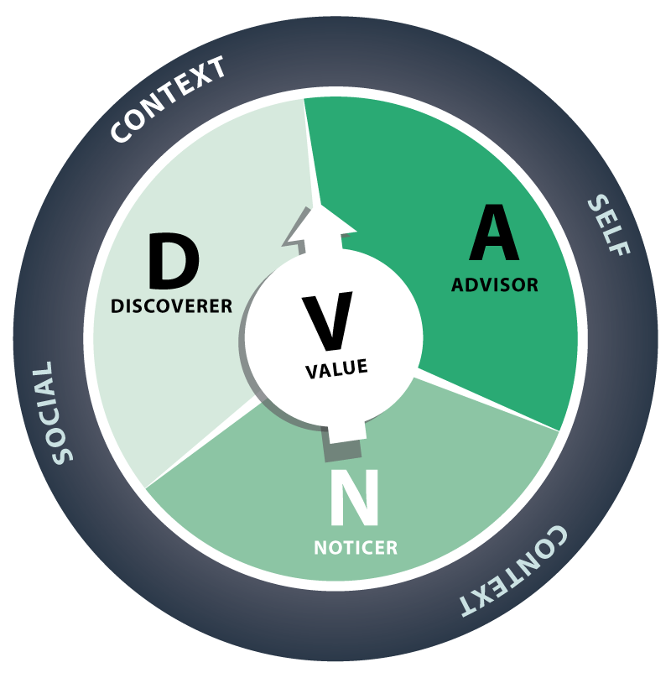

DNA-v is the developmental model acceptance and commitment therapy (ACT) and positive psychology to help adolescents manage emotions, connect with their values, utilize mindfulness, and develop healthy relationships. To understand more see [7 Steps for Helping School Refusal - DNA-V International (dnav.international)](https://dnav.international/article/7-steps-helping-school-refusal/).

For more information about ACT and the DNA-v model schools can request this through your link Educational Psychologist.

**Emotion Coaching**

Emotion Coaching is based on research by John Gottman and Joan DeClaire (1997), Dan Siegel (2001), and the Tuning into Kids Parenting Programme (Havighurst et al., 2013).

Emotion coaching is based on the understanding that all behaviour is a form of communication, and is driven by an emotional response. It believes that all emotions are acceptable, but not all behaviour. The approach, therefore, emphasises the importance of addressing the emotions that underlie behaviour ‘in the moment’ before setting limits or problem solving. Emotion coaching provides a staged approach to developing scripts of how to respond to pupil’s when their emotions become overwhelming. Emotion coaching is an effective strategy that promotes resiliency skills (Gus, Rose and Gilbert, 2015). See more at <https://www.emotioncoachinguk.com/>

For more information about Emotion Coaching schools can request this through your link Educational Psychologist.

**Anxiety**

If there are indications that the child is at risk of EBSA it will be important to build up a clear picture of exactly what elements of attending school are increasing their anxiety in order that best endeavours can be made to alleviate the anxiety. NICE (2013) recommend that CBT is considered for children and children with autism anxiety who have the verbal and cognitive ability to engage and there is emerging and growing evidence that CBT could reduce anxiety in children with ‘high-functioning’ ASD

Schools could consider using resources such as:

* The Homunculi Approach to Social and Emotional Wellbeing: A Flexible CBT Programme for Children on the Autism Spectrum or with Emotional and Behavioural Difficulties by Anne Greig
* Starving the Anxiety Gremlin by Kate Collins-Donnelly

It is also be appropriate to seek specialist, outside agency support such as the Child and Adolescent Mental Health Team (CAMHs).

**Capturing the child and child voice**

The Educational Psychology Service has developed a range of tools to help schools and professionals access pupil’s views regarding school and EBSA. These can be accessed via your link Educational Psychologist.

*Landscape of Fear (Kate Ripley, 2015)*

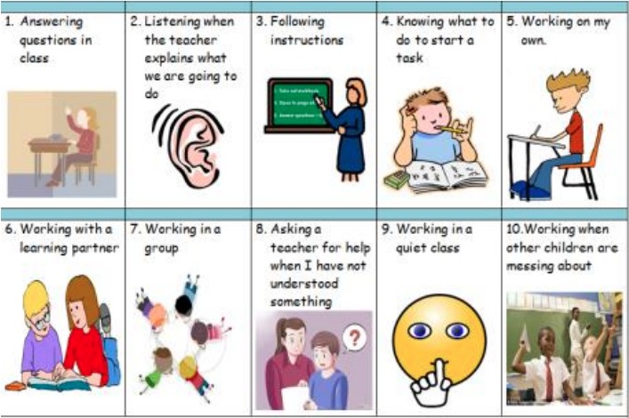Mapping the Landscape of Fear is a useful tool that can be used by school staff and others to explore sources of anxiety around school attendance. It examines child’s beliefs about the physical environment, the social environment and the learning environment in school.

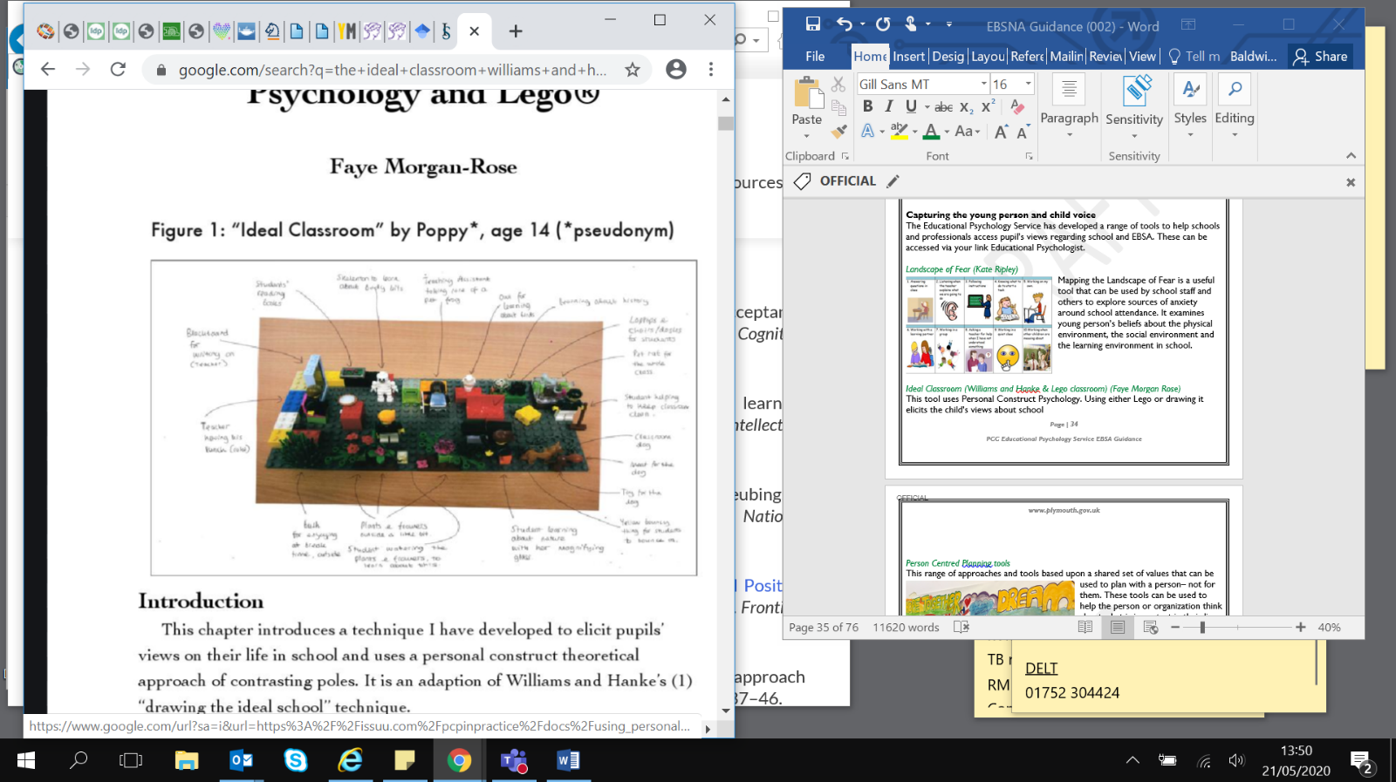*Ideal Classroom (Williams and Hanke, 2007) (Morgan Rose, 2016)*

This tool uses Personal Construct Psychology. Using either Lego or drawing it elicits the child’s views about school

*Person Centred Planning tools*

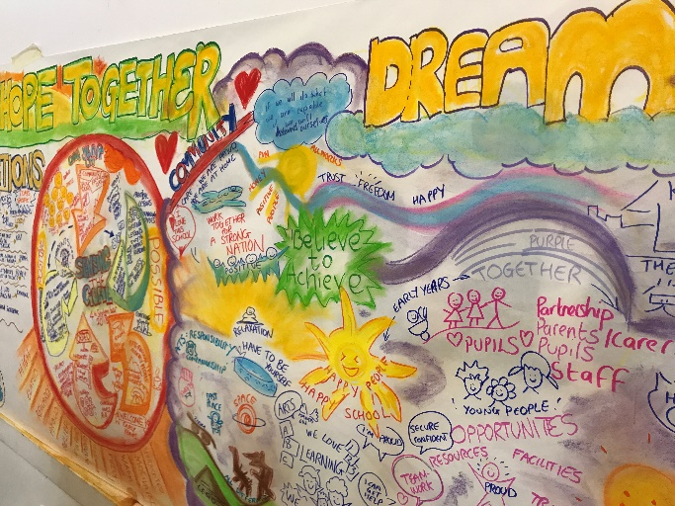This range of approaches and tools based upon a shared set of values that can be used to plan with a person– not for them. These tools can be used to help the person or organization think about what is important in their lives and also think about what would make a good future. For example a Planning Alternative Tomorrows with Hope (PATH). PATH is a creative planning tool that uses both process and graphic facilitation to create a shared vision of a positive future for individuals, families, teams and whole organisations. PATH draws on people’s ability to visualize different futures and to plan backwards from a future vision or dream and tell stories about how that vision can come into being. Pen portraits and all about me one page profiles will also be helpful.

**Whole school good practice**

Any successful work with an individual needs to be embedded in whole school systems. General good practice for promoting emotional well-being and positive mental health also applies to EBSA. The figure below outlines the culture, structures, resources and practice within a school that can promote wellbeing of staff and children, with particular reference to EBSA. A whole school audit can be found in Appendix 5.

**Transitions**

Literature has shown that peaks in the number of children with EBSA correspond with transition in educational phases. This is not surprising as children face significant changes**.**

Successful transition involves the child being supported to be able to make adjustments to fit in with their new environment.

Most children adjust to these changes over time. However children who experience higher levels of anxiety or who have experienced loss and separation may be vulnerable to developing or experience an exacerbation of EBSA behaviours. It is important that schools and parents provide appropriate support and any vulnerable children are flagged up early by the feeder school and an individual approach is taken.

Good transition practice involves effective exchange of information both pastoral and academic from primary to secondary school. It is really important if feeder schools flag up any early separation difficulties and past EBSA even if the issues were mild and attendance is now fine. We advise that secondary schools should specifically ask this information on any transition gathering forms.

Good transition also involves good communication with the child and their parents. Key to this is giving the children and their parent’s practical information.

Familiar school staff should discuss with children and their parents what are they are looking forward to and what they are worried about and this should be individually addressed. An example of support for this are ‘What if cards…’

|  |  |  |
| --- | --- | --- |
| **What if I don’t know where my classroom is…** | **What if someone calls me an unkind name…** | **What if I have nothing to do at break time…** |
| I will get my timetable from my school planner and see if I can work it out | I will try and walk away and not swear or shout | I could to the library |
| I will try and ask someone in my class | I will tell a teacher why I feel upset | I could buy a snack and eat it in the dining hall |
| I will ask my teacher | My teacher will deal with it and talk to that person | I could find my buddy |

**EBSA and School attendance**

The Education Act 1996 places a legal duty on all parents to ensure that their child has an education. When this education is provided in a school setting parents must ensure their child attends regularly. If the parent is unable to ensure this they can be held accountable for an offence under S.444 Education Act 1996; failure to secure the regular school attendance of a child. The term regular has recently been defined to mean ‘as prescribed by the school’. For the majority of pupils, this means attending school full time. Any unauthorised absence is therefore irregular attendance.

As with any law, the parameters are firm and the Education Act 1996 goes further as the offence is one of strict liability. This means there are only certain permitted defences the parent can use for their child missing school. One such defence is the child was unfit to attend school due to ill health. The parent must prove this to be the case. Only a Head Teacher can authorise absence from school. They may request supporting medical evidence from the parent which shows the pupil is unfit to attend school.

This request is often made to avoid the matter moving into a legal process. Medical evidence can include appointment cards; prescriptions, reports from medical professionals etc. The weight and value of the evidence is one for the Head Teacher to consider in their decision making of whether an absence is to be authorised or not. For schools with children experiencing EBSA and struggling with attendance, it is the Head Teacher’s decision whether to authorise absence or not.

Further guidance available at:

<https://www.plymouth.gov.uk/schoolroom/inclusionattendanceandwelfare/childrenmissingeducation>

<https://www.plymouth.gov.uk/schoolroom/inclusionattendanceandwelfare/provisionpupilsmedicalneeds>

**EBSA and Education Health and Care Needs Assessments**

Education Health Care Plans (EHCPs) are for children who have a special educational need or disability that cannot be met by the support that is available at their school or college setting. Most children with special educational needs will have help given to them without the need for an EHC Plan at the SEN support level.

In some cases children who display EBSA behaviours may have underlying special educational needs and require support above the SEN support level. If this is the case schools or parent can request that the local authority undertake an Education Health Care needs assessment.

In order to be able to decide whether an assessment should occur the Local Authority will need to see evidence that the school or college have taken appropriate action following the assess, plan, do and review cycle and there is evidence that the child or child has not made adequate progress or has only made progress because of a very high level of support.

Practice needs to be line with the review decision pathway. Found:

<https://www.plymouthonlinedirectory.com/media/2149/Graduated-Approach-to-Inclusion-Plan-and-Review-Part-2-/pdf/GraduatedApproachToInclusionPart2.pdf?m=637190065150330000>

An EHCP needs assessment may be considered if:

* Outcomes based planning demonstrates that over time professional advice has been followed but appropriate progress is still not evident
* Appropriate support has been sustained over a series of planning and review cycles and this has included a specific multi focused intervention programme with individual support
* There is a demonstrable and significant effect on pupils’ progress over time despite advice being taken and support in place
* Significant learning needs have been identified

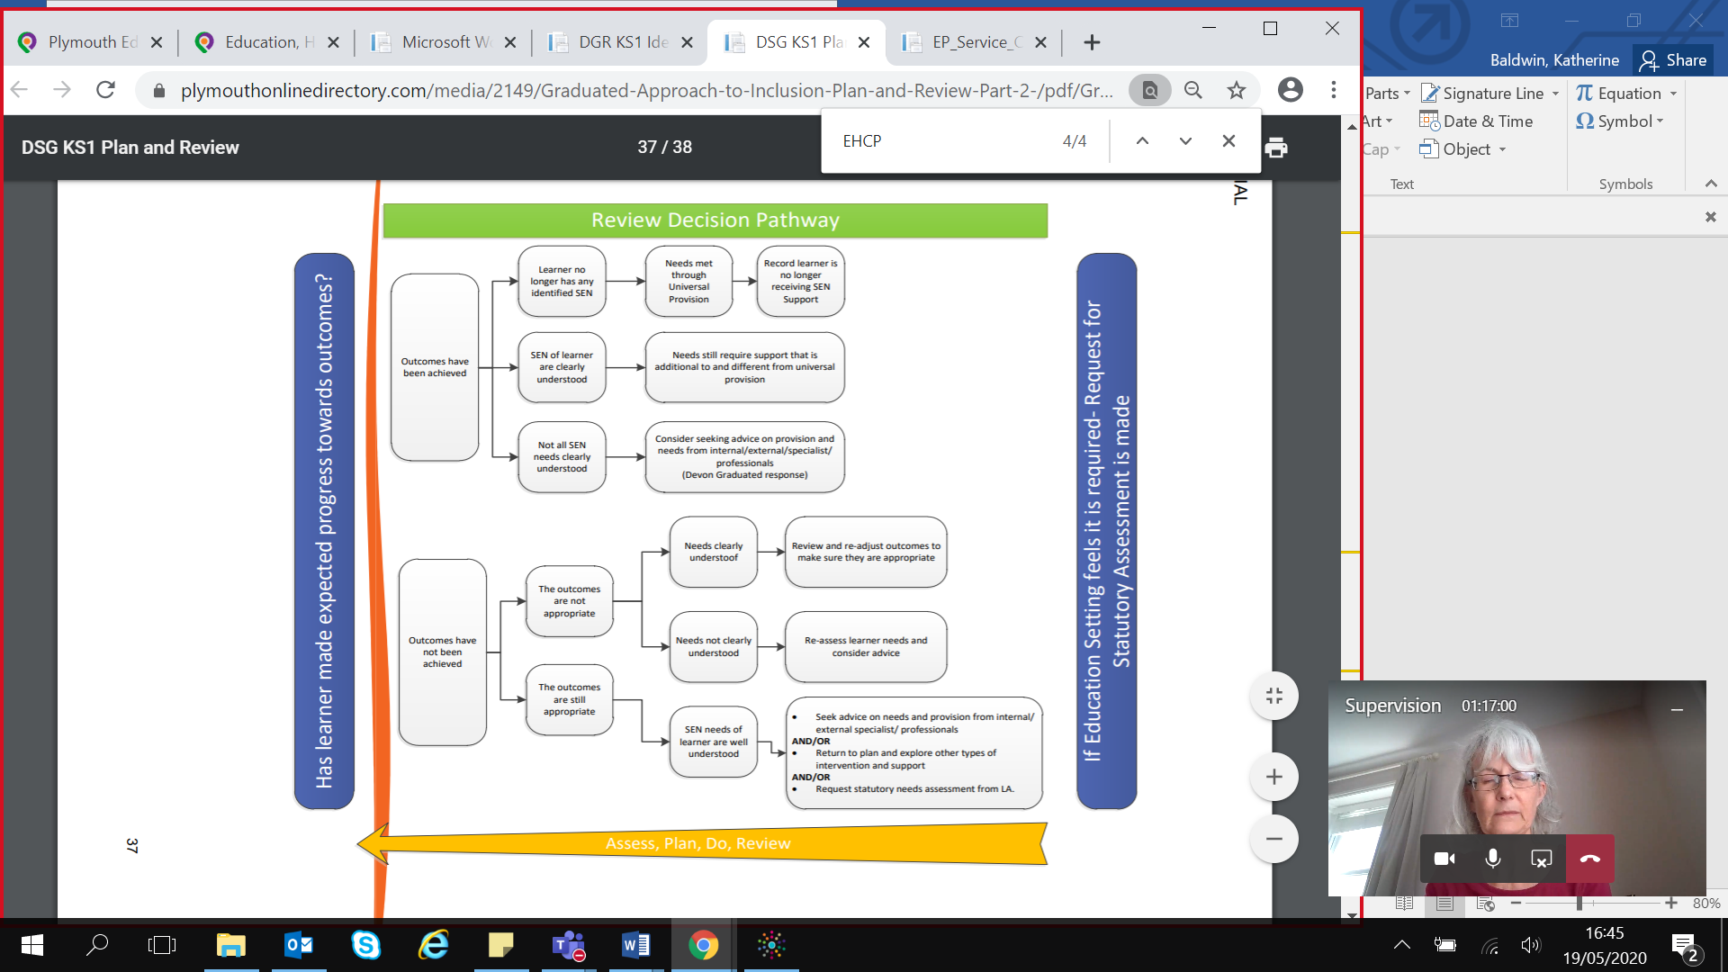

(Plymouth Graduated response)

**Local support and resources**

Information regarding local services and organisations can be found on the Plymouth Local Offer:

<https://www.plymouthonlinedirectory.com/plymouthlocaloffer>

**CAMHS (Child & Adolescent Mental Health Services)**

Community CAMHS Liaison Practitioners are embedded in the secondary schools in Plymouth as part of the Whole Schools Approach, individuals are assigned to specific schools to build positive working relationships. Our Liaison Practitioners also work closely with primary schools who should have a small group of practitioners who are familiar to them. Community CAMHS are able to offer Consultation involving the school and parents which may support in identifying any mental health needs, or services which may be available in the school or wider community. If there are concerns about mental health Community CAMHS can offer assessment of the child which may result in a targeted intervention. Assessments may also include school and or home observations, and written screening tools by the child or child, their parents/carers and the school. Interventions may include targeted group work, parent work, 1-1 work or low intensity CBT.

Contact details:

01752 421601

[Livewell.communitycamhs@nhs.net](mailto:Livewell.communitycamhs@nhs.net)



**CAMHS Community Duty Line**

This phone line is for all young people, parents and professionals in Plymouth who are open to CAMHs or not seeking advice, signposting, or emotional support. Self-referral can be considered with a professional utilising this phone line. Professional can seek anonymous support regarding young people (referrals by professionals cannot be made using this phone line).

Contact details:

01752 431613

Phone line Mon-Fri 12pm-5pm excluding bank holidays



**Communication Interaction Team**

The Communication Interaction Team works with children and young people who have speech, language and communication needs. This includes children and young people on the autism spectrum.

Our teachers and specialist support workers work closely with children, schools, parents, educational psychologists and a range of other professionals to cover the following:

* [Language support](https://www.plymouthonlinedirectory.com/plymouthlocaloffer/communicationinteractionteam/languagesupport)
* [Social communication/autism support](https://www.plymouthonlinedirectory.com/plymouthlocaloffer/communicationinteractionteam/socialandautism)

Contact details:

01752 668000

[accessearlyhelp@plymouth.gov.uk](mailto:accessearlyhelp@plymouth.gov.uk)



**Educational Psychology Service**

Educational Psychologists use psychology to support the educational progress, development, mental health and wellbeing of children and young people from 0-25 years with complex special educational needs and, or a disability.

<https://www.plymouthonlinedirectory.com/plymouthlocaloffer/educationalpsychologyservice>

We may provide support around EBSA in relation to:

* We support families, early years settings, schools and colleges. Our role usually involves **joint working** with a range of other professionals as part of a Team Around the Child or Child.
* The service also supports a wide range of needs by providing **training**, **consultation** and project work for adults, such as carers, teachers and early years practitioners, who work with children and young people.
* We conduct research and evaluation projects in order to achieve high-quality provision for children and young people.
* Educational Psychologists provide **consultation**, **assessment** and **advice** on strategies to promote positive outcomes.
* We undertake psychological assessment for all children and young people with special educational needs who require a statutory Education Health and Care Plan.

Contact details:

01752 224962

[psychology.service@plymouth.gov.uk](mailto:psychology.service@plymouth.gov.uk)



**Inclusion, Attendance and welfare services.**

The Inclusion, Attendance and Welfare Service consists of a team of skilled professionals, including Educational Welfare Officers, experienced in dealing with the most vulnerable children in Plymouth.

The team provides advice to schools around EBSA in relation to:

* Child protection and safeguarding
* Attendance and behaviour
* Legal responsibilities
* Children Missing Education

In addition it:

* Supports parents and schools to ensure children access their entitlement to an efficient and suitable education
* Identifies and shares good practice in schools, signposts and supports referrals to appropriate intervention
* Monitors attendance data
* Provides advice, guidance and training

Contact details:

01752 307405

[IAWS@plymouth.gov.uk](mailto:IAWS@plymouth.gov.uk)



**Plymouth Information, Advice and Support for SEND (PIAS)**

Contact details:

01752 258933 / 0800 953 1131

[pias@plymouth.gov.uk](mailto:pias@plymouth.gov.uk)

****PIAS provides information, advice and support relating to Special Educational Needs and Disabilities (SEND) for parents, carers, children and young people within the Plymouth Local Authority area. PIAS work 1:1 with parents and carers with support at meetings and with education and training issues.

**Livewell Southwest School Nursing Team**

School nursing team works with children, their parents and professionals to ensure young people’s health needs are met and supported – at home, at school and in the wider community. The experienced registered nurses and health workers offer confidential advice and support on a range of physical and emotional health issues.

Contact details PHN Hub:

01752 434008

Livewell.phnadminhub@nhs.net



**Not Fine in Schools**

Not Fine in School is a parent-led organisation supporting families experiencing school refusal & attendance difficulties & raising awareness of related issues.

<https://notfineinschool.org.uk/>

**Further resources**

**Anxiety Management**

* Starving the Anxiety Gremlin: A Cognitive Behavioural Therapy Workbook on Anxiety Management for Children By Kate Collins-Donnelly
* What to Do When You Worry Too Much: A Kid's Guide to Overcoming Anxiety By Dawn Heubner
* Information about Anxiety Young Minds <https://youngminds.org.uk/find-help/conditions/anxiety/>
* Mighty Moe by Lacey Woloshyn <http://www.cw.bc.ca/library/pdf/pamphlets/Mighty%20Moe1.pdf>
* Worksheets for anxiety – Anxiety BC <https://www.anxietybc.com/parenting/worksheets>
* Anxiety self-help guide – Mood Juice <https://www.mcgill.ca/counselling/files/counselling/anxiety_moodjuice_self_help_guide.pdf>
* Cognitive Behavioural Therapy Skills Training Workbook – Hertfordshire Partnership NHS <http://inabook.co.za/wp-content/uploads/2016/08/CBT-workbook-good-to-use.pdf>
* Anxiety by Paul Stallard -Examples of activities <http://tandfbis.s3.amazonaws.com/rt-media/pp/resources/CBTCHILD/worksheets.pdf>
* Understanding anxiety and panic attacks Mind <https://www.mind.org.uk/media/1892482/mind_anxiety_panic_web.pdf>
* The Anxious Child: A booklet for parents and carers wanting to know more about anxiety in children and children . <https://www.mentalhealth.org.uk/publications/anxious-child>

**General Emotional Wellbeing & Mental Health Literature**

* Managing Your Mind: The Mental Fitness Guide By Gillian Butler and Tony Hope (for older children )
* Get Out of Your Mind and Into Your Life for Teens By Joseph V. Ciarrochi , Louise Hayes and Ann Bailey.
* Stuff That Sucks: Accepting what you can't change and committing to what you can By Ben Sedley
* Promoting Emotional Resilience - Toolkit <http://hbtg.org.uk/wp-content/uploads/2015/06/KAN-Emotional-resilience-toolkit.pdf>
* The Thriving Adolescent: Using Acceptance and Commitment Therapy and Positive Psychology to Help Teens Manage Emotions, Achieve Goals, and Build Connection By Louise Hayes
* Feeling Good: Promoting children's mental health Centre for Mental Health <https://www.centreformentalhealth.org.uk/blog/centre-mental-health-blog/how-do-you-look-after-your-wellbeing>
* Parent survival guide <https://youngminds.org.uk/find-help/for-parents/parents-survival-guide/>
* Dealing with Feeling by Tina Rae. Published by Lucky Duck
* I am special by Peter Vermeulon.
* A Volcano in My Tummy by Elaine Whitehouse and Warwick Pudney.
* Emotional Literacy assessment and intervention by Southampton Psychology Service. Published by GL Assessment Limited. (Available for both Primary and Secondary)
* Online course on how to support children with mental health difficulties [www.minded.org.uk](http://www.minded.org.uk)
* MindEd for families: MindEd for Families has online advice and information from trusted sources and will help you to understand and identify early issues and best support your child. [https://www.minded.org.uk/families/index.html#](https://www.minded.org.uk/families/index.html)
* MindEd for professionals: MindEd has e-learning applicable across the health, social care, education, criminal justice and community settings. It is aimed at anyone from beginner through to specialist. https://www.minded.org.uk/Catalogue/TileView

**Local Authority Guidance**

* Devon: <http://www.babcock-education.co.uk/ldp/absa>

<https://www.devonsafeguardingchildren.org/documents/2016/07/guidance-on-anxietybased-school-avoidance.pdf>

* Derbyshire: <https://schoolsnet.derbyshire.gov.uk/site-elements/documents/keepingchildren-safe-in-education/emerging-school-safeguarding-themes/emotionally-basedschool-refusal-guide.pdf>
* North Somerset: <https://thinkleftdotorg.files.wordpress.com/2015/10/ebsr.pdf>
* West Sussex: <http://schools.westsussex.gov.uk/Page/10483>

**Books for young children**

* The Goodnight Caterpillar: A Relaxation Story for Kids by Lori Lite
* Huge bag of worries by Virginia Ironside
* The Koala that could by Rachel Bright
* Silly Billy by Anthony Browne
* Willy the Wimp by Anthony Browne
* Owl Babies by Martin Wadell
* How to catch a star by Oliver Jeffers
* Willy and the Wobbly house by Margot Sunderland
* The boy and the bear by Lori Lite
* Starting school by Janet Ahlberg
* Back to school tortoise by Lucy M. George
* Gotcha Smile by Rita Philips Mitchell
* Halibut Jackson by David Lucas
* Giraffes can’t dance by Giles Andreae

**Recommended Resources Autism**

**Books:**

* Autism from Diagnostic pathway to Intervention: Checklists to support diagnosis, analysis for target setting and effective intervention strategies by Kate Ripley
* Autistic Spectrum Disorders – Practical Strategies for Teachers and Other Professionals by Northumberland County Council Communication Support Services UK.
* Autistic Spectrum Disorders in the Secondary School (Autistic Disorder Support Kit) by Lynn Pimley
* Autism in the Secondary Classroom by Joy Beaney and Penny Kershaw
* Understanding How Children and Adolescents Think and Learn by Paula Jacobsen.
* Education and Care for Adolescents and Adults with Autism by Kate Wall
* Exams: Guidelines for parents and teachers of children with autism published by The National Autistic Society
* Autism: Supporting your teenager by Caroline Hattersley
* Understanding How Asperger Children and Adolescents Think and Learn by Paula Jacobsen
* Sensory Strategies: Practical ways to help children and children with autism learn and achieve by Corinna Laurie.
* The Social Play Record: A Toolkit for Assessing and Developing Social Play from Infancy to Adolescence by Chris White.
* Teaching children with Autism to Mind Read by Patricia Howlin, Simon Baron-Cohen and Julie A. Hadwin.
* The Incredible 5-point Scale by Kari Dunn Buron and Mitzi Curtis.
* Starving the Anxiety Gremlin: A Cognitive Behavioural Therapy Workbook on Anxiety Management for Children (Gremlin and Thief CBT Workbooks) by Kate Collins-Donnelly
* Starving the Anger Gremlin: A Cognitive Behavioural Therapy Workbook on Anger Management for Children (Gremlin and Thief CBT Workbooks) by Kate Collins-Donnelly
* Banish Your Self-Esteem Thief: A Cognitive Behavioural Therapy Workbook on Building Positive Self-esteem for Children (Gremlin and Thief CBT Workbooks) by Kate Collins-Donnelly
* Banish Your Body Image Thief (Gremlin and Thief CBT Workbooks) by Kate Collins-Donnelly
* Martian in the Playground: Understanding the Schoolchild with Asperger’s Syndrome by Clare Sainsbury.
* The New Social Story Book by Carol Gray.
* Comic Strip Conversations by Carol Gray.
* Time to Talk by Alison Schroeder.
* Talkabout: A Social Communication Skills Package by Alex Kelly.
* Dealing with Feeling by Tina Rae.
* I am special by Peter Vermeulon.
* A Volcano in My Tummy by Elaine Whitehouse and Warwick Pudney.
* Emotional Literacy assessment and intervention by Southampton Psychology Service. Published by GL Assessment Limited. (Available for both Primary and Secondary)

**Websites:**

* Do2learn - [www.do2learn.com/](http://www.do2learn.com/)
* Setbc - https: [www.setbc.org/students/Pages/PictureSET.aspx](http://www.setbc.org/students/Pages/PictureSET.aspx)
* Resources for Inclusion: [www.resourcesforinclusion.co.uk/](http://www.resourcesforinclusion.co.uk/)
* The Gray Center (Comic Strip Conversations and Social Stories):
* [www.thegraycenter.org/](http://www.thegraycenter.org/)
* Visual aids for learning: [www.visualaidsforlearning.com](http://www.visualaidsforlearning.com)
* <http://autismteachingstrategies.com/wp-content/uploads/2013/05/CBT-Worksheets-Sets.pdf>

**References**

* Baker, M & Bishop, F. (2015). Out of school: a phenomenological exploration of non-attendance. Educational Psychology in Practice, 31: 4, 354-368.
* Gaus, V.L., (2011) Cognitive behavioural therapy for adults with autism spectrum disorder, Advances in Mental Health and Intellectual Disabilities, Vol. 5 Issue: 5, pp.15-25
* Gonzálvez, C., Kearney, C. A., Jiménez-Ayala, C. E., Sanmartín, R., Vicent, M., Inglés, C. J., & García-Fernández, J. M. (2018). Functional profiles of school refusal behavior and their relationship with depression, anxiety, and stress. *Psychiatry research*, *269*, 140-144.
* Gottman J. M, & DeClaire, J. (1997) *The heart of parenting: How to raise an emotionally intelligent child.* Simon & Schuster: New York.
* Gulliford, A., & Miller, A. (2015). Coping with life by coping with school? School refusal in young people. In *Educational Psychology* (pp. 299-321). Routledge.
* Gus, L., Rose, J., & Gilbert, L. (2015). Emotion coaching: A universal strategy for supporting and promoting sustainable emotional and behavioural well-being. *Educational & Child Psychology*, *32*(1), 31-41
* Havighurst, S. S., Wilson, K. R., Harley, A. E., Kehoe, C., Efron, D., & Prior, M. R. (2013). “Tuning into Kids”: Reducing young children’s behavior problems using an emotion coaching parenting program. *Child Psychiatry & Human Development*, *44*(2), 247-264.
* Havik, T., Bru, E., &  Ertesvåg, S. K. (2015). School factors associated with school refusal-and truancy-related reasons for school non-attendance. *Social Psychology of Education, 18 (2),* 221-240.
* Hayes, L, L. & Ciarrochi, J, V. (2015) *The thriving adolescent: Using acceptance and commitment therapy and positive psychology to help teens manage emotions, achieve goals, and build connection.* New Harbinger Publications
* Heyne, D., Gentle-Genitty, C., Landell, M. G., Melvin, G., Chu, B., Gallé-Tessonneau, M., ... & Johnsen, D. B. (2019). Improving school attendance by enhancing communication among stakeholders: establishment of the International Network for School Attendance (INSA). *European child & adolescent psychiatry*, 1-8
* Kearney, C. A. (2006). Confirmatory factor analysis of the School Refusal Assessment Scale-Revised: Child and parent versions. *Journal of Psychopathology and Behavioral Assessment*, *28*(3), 139-144.
* Kearney, C.A. and Silvermann, W.K. (1990) A preliminary analysis of afunctional model of assessment and treatment of school refusal behaviour. Behaviour Modification 14, 340-366.
* Kearney, C.A., & Spear, M. (2012) School refusal behavior. School-based cognitive-behavioral interventions. En R.B. Mennutti, A. Freeman y R.W. Christner (Eds.), Cognitive-behavioral interventions in educational settings: A handbook for practice (pp. 161-183). New York, NY: Taylor & Francis
* King, N. & Bernstein, G. (2001). School Refusal in Children and Adolescents: A Review of the Past 10 Years. Journal of American Academy of Child Adolescent Psychiatry, 2001, 40(2):197– 205.
* Maric, M., Heyne, D. A., de Heus, P., van Widenfelt, B. M., & Westenberg, P. M. (2012). The role of cognition in school refusal: an investigation of automatic thoughts and cognitive errors. *Behavioural and cognitive psychotherapy*, *40*(3), 255-269.
* Maynard, B. R., Brendel, K. E., Bulanda, J. J., Heyne, D., Thomspon, A. & Pigott, T. D. (2015) Psychosocial interventions for school refusal with primary and secondary students: A systematic review. Campbell Systematic Reviews 2015:12. DOI: 10.4073/csr.2015.12
* McLeod, B.D., Wood, J.J., Klebanoff, S. (2015) Advances in evidence-based intervention and assessment practices for youth with an autism spectrum disorder. Behavior Therapy, Volume 46, 1-6
* Morgan-Rose, F. (2016). *The ideal classroom: perspectives of young people attending a nurture group* (Doctoral dissertation, University of Birmingham)
* NICE (2013). Social anxiety disorder: recognition, assessment and treatment. <https://www.nice.org.uk/guidance/cg159>
* Nuttall, C., & Woods, K. (2013). Effective intervention for school refusal behaviour. *Educational Psychology in Practice*, *29*(4), 347-366.
* Ozsivadjian, A. & Knott, F. (2016) Anxiety problems in children with autism spectrum disorder: a case series Clin Child Psychol Psychiatry. 2011 Apr;16(2):203-14
* Reaven, J., Blakeley-Smith, A., Culhane-Shelburne, K. and Hepburn, S. (2012), Group cognitive behavior therapy for children with high-functioning autism spectrum disorders and anxiety: a randomized trial. Journal of Child Psychology and Psychiatry, 53: 410–419.
* Ripley, K. (2015). *Autism from Diagnostic Pathway to Intervention: Checklists to Support Diagnosis, Analysis for Target-setting and Effective Intervention Strategies*. London: Jessica Kingsley Publishers
* Siegel, D. J. (2001). Toward an interpersonal neurobiology of the developing mind: Attachment relationships, “mindsight,” and neural integration. *Infant Mental Health Journal: Official Publication of The World Association for Infant Mental Health*, *22*(1‐2), 67-94
* Steensel, F.J.A., Zegers, V.M. & Bögels, S.M. (2017) Predictors of Treatment Effectiveness for Youth with ASD and Comorbid Anxiety Disorders: It all Depends on the Family. J Autism Dev Disord 47: 636.
* Taylor, C. (2012) Improving attendance at school. London DFE
* Thambirajah M,S., Grandison K.J., and De-Hayes L. (2008) Understanding School refusal: a handbook for professionals in education, Health and Social Care. Jessica Kingsley, London, UK
* Ting, V. & Weiss, J.A. (2017) Emotion Regulation and Parent Co-Regulation in Children with Autism Spectrum Disorder. J Autism Dev Disord 47: 680-689
* Williams, J, & Hanke, D. (2007) Do you want to know what sort of school I want? Optimum features of school provision for pupils with Autistic Spectrum Disorders. *GAP Journal,* 124-137.

**Appendix 1 – Vulnerability assessment scale**



|  |
| --- |
| Educational Psychology Service  **EBSA Vulnerability Assessment Scale** |

Please complete the following scale to help us assess a child or child’s (CYP’s) vulnerability, or risk of EBSA.

The factors to consider are examples and not intended to represent an exhaustive list. They should be considered alongside the Plymouth Educational Psychology Service EBSA Guidance Document. The scores should be based on an aggregation across those that know the child/child well in the different environments they participate in. Ideally, the score should represent an agreement between the different people that contribute to it.

Score on a scale of 1-5, where 1 is no concerns and 5 is extreme concerns. That way a higher total score indicates a higher estimate of risk of EBSA.

|  |  |  |  |
| --- | --- | --- | --- |
| Name of CYP |  | DOB |  |
| Current setting |  | Year |  |
| Next setting (if appropriate) |  |  |  |

|  |  |  |  |
| --- | --- | --- | --- |
| **Item** | **Factors to consider** | **Comments** | **Score** |
| Stability at home | Relationships with others at home, movement between parent/carers homes, access to extended family, CIN/CP/LAC |  |  |
| Relationships with school staff | Stability, sense of security, nature and frequency of contact, fear of teachers |  |  |
| Relationships with other CYP | Stability of friendships, closeness, nature and frequency of contact, breadth and depth, in- or out- of school friends, experiences of being bullied or intimidated |  |  |
| Completion of work | Evidence of homework, maintenance of grades, have SEND needs been recognised and supported. |  |  |
| Experience of school prior to EBSA | Attendance, relationships, enjoyment, sense of belonging, loneliness, work, belief in self as a learner. |  |  |
| Awareness and self-regulation | Ability to identify and manage emotions, can accept support to calm down, can positively resolve conflict, confidence, social skills to develop relationships, management of sensory environment in and out of school. |  |  |
| Relevant events prior to EBSA. | Family members illness, parent separation, financial difficulties, change in family or living circumstances, experience of abuse, bereavements, school related transitions or changes |  |  |
| Exposure to ACEs; | Family vulnerability e.g. domestic abuse, increase in the use of substances, crime, adult health concerns, family history of mental health concerns |  |  |
| Physical or medical health concerns | How do these effect access to the school environment; how do they impact on attendance rates e.g. regular hospital appointments/treatment, have reasonable adjustments been made to accommodate CYP wellbeing, health anxiety, personal or family vulnerability, loss of access or enjoyment of hobbies and physical activity. |  |  |
| Parent/carer concerns about CYP returning to school following a period of EBSA | Separation anxiety, adjustments to change, adjustments to new environments, concerns with preparation for SEND provision. |  |  |
| Has opportunity to express opinions and concerns and view is valued | Do adults around the CYP (parents, extended family, school staff, support agencies) ask the CYP’s opinion, offer them a space to talk and value their contribution and concerns. Is the CYP able to express their views coherently and confidently. Are adults aware of the ‘voice of the child’. |  |  |
|  | TOTAL |  |  |

|  |  |
| --- | --- |
| Date of completion: |  |
| Completed by: |  |
| In discussion with: |  |

**Appendix 2 – Information gathering from school**

|  |
| --- |
| _____________ *is currently experiencing difficulties attending school which we feel may be due*  *to emotional distress. We would like to gain a picture of how they are in school. As an*  *adult who works with __________ please complete the questionnaire below.*  Your name______________ Lesson/Activity_________ |
| Please describe the child________ |
|  |
| What are ________’s strengths? |
|  |
| What is going well for ___________? |
|  |
| What does ___________’s find difficult? |
|  |
| How does ___________ get on with their peers? |
|  |
| How does_____________ get on with you and other adults? |
|  |
| Is______________ engaged and motivated with their learning? Are they making progress? If not why not? |
|  |
| Have you observed any emotional difficulties at school? What have they been? When do/did they occur? |
|  |
| What support do you provide for___________? How do they respond to this? |
|  |
| What is your understanding of ___________’s attendance? |
|  |
| What do you think would help __________ in school? |
|  |

**Appendix 3 – Information gathering and integration**

|  |  |
| --- | --- |
| Name: | School: |
| Year Group: | Key staff in school: |
| Other agencies involved: |  |
| Description of behaviour | |
|  | |
| Risk facts school, child and family | |
|  | |
| Strengths and protective factors | |
|  | |
| Formulation and integration of various factors | |
|  | |

**Appendix 4 – Example of support plans**

|  |  |  |  |
| --- | --- | --- | --- |
| **Support Plan** | | | |
| Name: | | Date agreed: | |
| *At school these things can make me upset/things I find difficult:* | | | |
| *My key adults in school is/are:*  When I can speak to my key adult(s):  Where I can speak to my key adult(s): | | | |
| *Until ________ my return to school plan includes the following changes to my attendance:*  (Identify any change to days or times attending school) | | | |
| *Changes to my timetable include:*  (Identify any changes needed and what should happen/where they are expected instead) | | | |
| *Any other changes include:*  Identify any other changes to routines (break, lunchtimes, changes between lessons etc.) classroom expectations (not expected to read aloud, work in pairs etc.) or homework | | | |
| *When I start to get upset, I notice these things about myself:* | | | |
| *When I start to get upset, others notice these things about me:* | | | |
| *Things I can do to make myself feel better when I’m in school are:* | | | |
| *Things that other people (staff and friends) can do to help me feel better when I’m at school:* | | | |
| *Things that my family can do to support me to attend school:* | | | |
| *Places where I can go to in school where I feel safe and supported:* | | | |
| This plan will be reviewed regularly so that it remains helpful.  *Review date:* | | | |
| *My signature* | *Key adults in schools signature* | | *Parent signature* |
| *Other people who have access to the plan are:* | | | |

|  |  |  |  |
| --- | --- | --- | --- |
| **Support Plan** | | | |
| Name: | | Date agreed: | |
| *At school these things can make me feel upset:* | | | |
| *My school support person/s is:*  *Details of checking in with my support person (When and Where)* | | | |
| *Until ________ my return to school plan includes the following changes to my attendance:*  (Identify any change to days or times attending school) | | | |
| *Changes to my timetable include:*  (Identify any changes needed and what should happen/where they are expected instead) | | | |
| *Any other changes include:*  Identify any other changes to routines (break, lunchtimes, changes between lessons etc.) classroom expectations (not expected to read aloud, work in pairs etc.) or homework | | | |
| *When I start to get upset, I notice these things about myself:* | | | |
| *When I start to get upset, others notice these things about me:* | | | |
| *Things I can do to make myself feel better when I’m in school are:* | | | |
| *Things that other people (staff and friends) can do to help me feel better when I’m at school:* | | | |
| *Things that my family can do to support me to attend school:* | | | |
| *Places where I can go to in school where I feel safe and supported:* | | | |
| This plan will be reviewed regularly so that it remains helpful.  *Review date:* | | | |
| *My signature* | *Key adults in schools signature* | | *Parent signature* |
| *Other people who have access to the plan are:* | | | |

**Appendix 5 – Whole School Audit**

|  |  |  |  |
| --- | --- | --- | --- |
| Whole school systems for promotion of emotional well-being and prevention of EBSA | | | |
|  | Whole school provision currently available | In need of development | Comments/Next steps (Including by whom and when) |
| School culture and ethos | | | |
| Committed and inclusive senior management team – values all students and allows them to feel a sense of belonging |  |  |  |
| All staff working within school are valued. Clear protocols regarding emotional support and stress management for staff including supervision |  |  |  |
| Continuous professional development for all staff which makes clear the promotion of positive emotional health and wellbeing is everybody’s responsibility (Including EBSA) |  |  |  |
| The importance of pupil voice and viewing the child holistically are approaches which are embedded within the culture of the school |  |  |  |
| Recognition of the importance of communication and partnership working with parents and external agencies |  |  |  |
| School systems, policy and practice | | | |
| Clear policies on attendance, behaviour, bullying, equality and transition which sets out the responsibilities for all and the support in place |  |  |  |
| Curriculum includes the teaching of resilience, coping and social skills |  |  |  |
| Curriculum appropriately differentiated according to individual need |  |  |  |
| Whole school systems for promotion of emotional well-being and prevention of EBSA | | | |
|  | Whole school provision currently available | In need of development | Comments/Next Steps (Including by whom and when) |
| Promotion of supportive literature regarding emotional well-being and mental health for children and parents |  |  |  |
| Clear roles and responsibilities for SENCO and emotional well-being leads |  |  |  |
| A member of senior staff is responsible for the over-seeing arrangements for EBSA students |  |  |  |
| Clear systems in place for the early identification of schools avoidance |  |  |  |
| Nominated member of who has a responsibility to investigate and act on concerns |  |  |  |
| Staff are aware as to whom they should convey any concerns regarding EBSA |  |  |  |
| Provision of interventions within a graduated response – assess, plan, do and review |  |  |  |
| Staff are aware of the role of other agencies and local arrangements with regard to assessing and supporting students experiencing EBSA |  |  |  |
| Access to indicated provision e.g. safe places within the school, key persons |  |  |  |
| All staff are aware of specific strategies and programmes in place to support those experiencing EBSA |  |  |  |